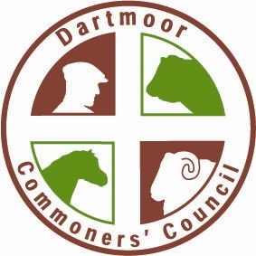

DARTMOOR COMMONERS’ COUNCIL

DETAILS OF FORTHCOMING ELECTIONS 2024

The following members of the Commoners’ Council will have served their term as at 30 June 2024 & shall be eligible for re-appointment, unless they choose not to stand again or other nominations are put forward, in which case there shall be an election.

COUNCILLORS DUE FOR ELECTION

AND

DATES ELECTIONS WILL TAKE PLACE

QUARTER & DATE | MORE THAN 10 LUs | LESS THAN 10 LUs
NORTH  Tuesday 11 June | Mr John Cooper  Ms Tracy May | Mrs Kate Little
Nominations to be in by Friday 31 May 2024
SOUTH  Wednesday 12 June | Mr Anton Coaker  Mr Philip French | Filled
Nominations to be in by Friday 31 May 2024
EAST  Thursday 13 June | Mrs Charlotte Faulkner  Mr John Jordan | Mr Ken Edwards
Nominations to be in by Monday 3 June 2024
WEST  Monday 17 June | Mr George Hill  Mr Mark Radmore | Mr Robert Leigh
Nominations to be in by Friday 7 June 2024

All commoners nominated, nominating or voting, must have paid their contributions for the current financial year. No contributions will be accepted at the election meetings.

